# Business Graph User Guide

This application is transforming CSV based tables into Marimekko and Punchcard graphs allowing to grasp at a glance numeric information embedded inside pivot tables based on the CSV underlying data.

# Prerequisite

To use the businessgraphs application, one needs to

1. Have a PC with Google Chrome web browser installed (version >56)
2. A Google account
3. CSV data ready for pivot table analysis

# EIA CSV data table

To provide a good coverage of businessgraphs, we are using a data table which is providing energy data coming from the International Energy Agency (EIA). This agency as for mission to cover the world energy production and consumption per various facets which is a nice use case to show businessgraphs operating modes.

We need to explain what is this data about to make sense and provide context for the present documentation.

Selecting this very important topic, energy, and showing the operating modes of businessgraphs to show results and benefits seemed a good opportunity designing such a documentation.

We are now going to spend some time about the definition of EIA data to be able to understand the course of action of this documentation.

It’s important to have a good understanding to be able to follow the rest of this documentation.

## EIA data

One can see the output of Energy data on EIA website: <https://www.iea.org>

The data is available by country in a Sankey diagram format for Energy Balance and Energy Final Consumption.

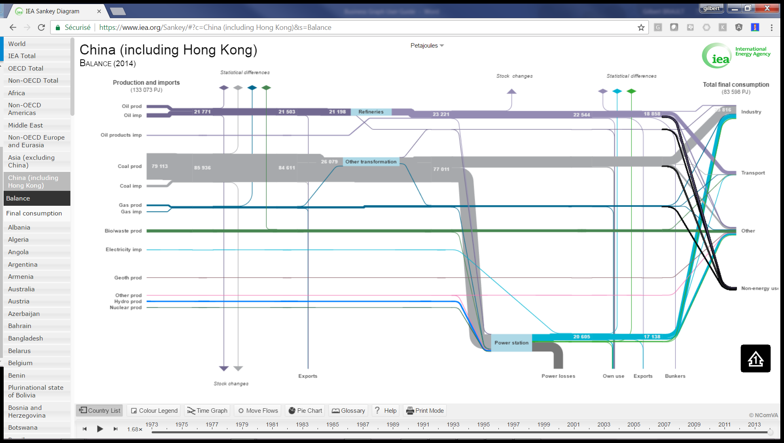

Here is the associated link for Energy Balance of China (Including Hong Kong) [https://www.iea.org/Sankey/#?c=China (including Hong Kong)&s=Balance](https://www.iea.org/Sankey/%23?c=China%20(including%20Hong%20Kong)&s=Balance)

Results are available in Million tons’ oil equivalent (Mtoe) or Peta Joules (PJ)

If we are looking the PJ results, it’s what one can read for this country and the following final consumption bins in 2014:

* Industry => 41 247 PJ
* Transport => 11 331 PJ
* Other => 24 336 PJ
* Non-Energy => 6 684 PJ

This data is available for years 1973 to 2014.

# Operating Modes